TENDER NO.01

M/o Religious Affairs & Interfaith Harmony

(Serving of Lunch/High Tea, Stage Decoration Prayer Mates etc at Pak China Center.)

This Ministry will organize two days Seerat Conference therefore, multiple services are required for arrangements of Seerat Conference, 2023 which will be held on 12 Rabiul Awwal 1445 AH (27-28th September, 2023) (Subject to appearance of moon) at Islamabad. The detail of items required is as under: -

Detail of Material / Services Required at Pak China Center.

S. # | Items Required | Proposed Qty
1 | Serving of Lunch and high-tea to the participants of Seerat Conference & catering Services (Approx. 700 persons), includes:  - Lunch, (as per Menu)  - High tea, (as per Menu)  - Catering services at the venue | 700
2 | Stage decoration/flowering etc.
3 | Drinking water bottles (Approx. 250 ml each) | 2000
4 | Lunch Boxes (Pulao, 1-Kabab, Chicken-piece, Raita/Salad, Drinking water bottles (Approx. 250 ml each)) | 300
5 | Prayer mates | For 300 persons

Lunch and High-tea (Pak China center)
Menu for Lunch | Menu for High-Tea
Salad  Assorted Salad, Raita  Main Course  Mutton Qorma  Chicken Baryani,  Chicken Seekh Kabab  Rogni Nan  Dessert  Fruit-Trifle | Bakery Biscuits (Good quality)  Fruit Cake (Fresh and good quality)  Tea / Coffee (rate may be quoted separately)
Note: Kernal Basmati White Rice may be used for Baryani. The standard of quantity & quality of meet (Mutton, Chicken etc.) & other items will be observed.

Catering (Pak China center)
Catering may include, but not limited to (Unit rate may be quoted, supply order will be issued as per requirement):
- VVIP Chairs for stage
- Sofa
- Carpets for Stage (Mention Size)
- Chairs (rates of different types of chairs may be quoted separately)
- VIP Dining sitting (Chairs & Table) for Approx. 50 Persons
- Dinning items for participants
- Podium/ Dias (as per sanctity/ glory of event)
- Stage table (as per sanctity/ glory of event)
- Prize table
- Separator Curtain for female dinning place (Kanaat)
- Red Carpet (Runner) for Lobby of Venue (Mention Size)
Stage decoration/flowering etc. (Pak China center)
Stage decoration includes, but not limited to, flowering on the stage, stage table & prize table. Flowering may include roses, lilies, marigolds. The price may be quoted per running foot basis (1’ × 1’ running foot, 1’ × 4” running foot, standing bookey, VIP-table bookey). The pictures of the stage are under for ready reference.
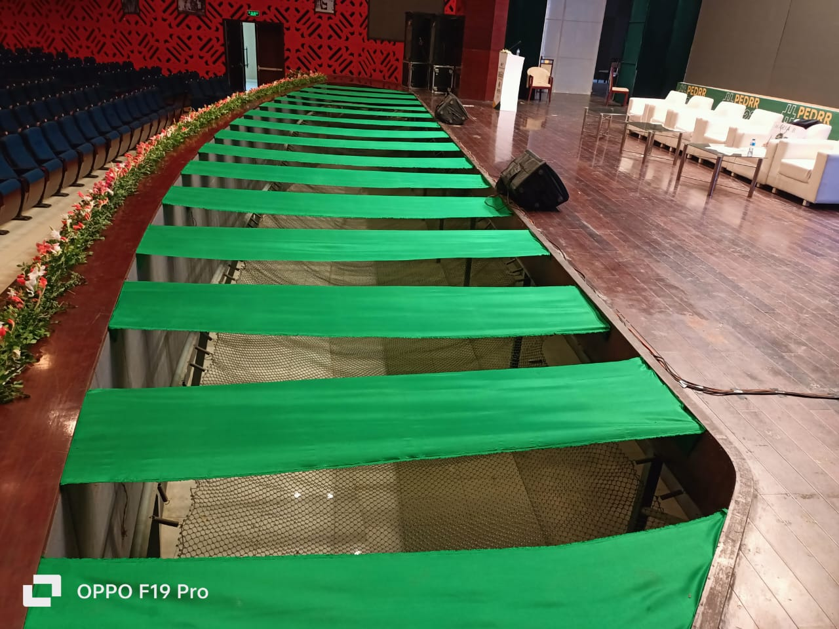
Figure 1 Pak China Center
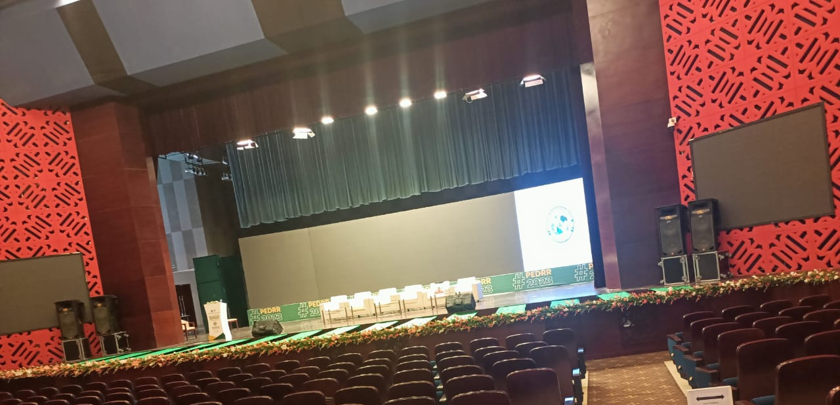
Figure 2 Pak China Center

Drinking water bottles (Pak China center)
The brand of drinking water bottles should be registered by the food authorities and should not be banned by any food authority in Pakistan.
Lunch Boxes (Pak China center)
The menu of lunch boxes is Pulao, 1-Kabab, Chicken-piece, Raita/Salad, Drinking water bottles (Approx. 250 ml each)). Kernal Basmati White Rice may be used for Pulao. The standard of quantity & quality of meet & other items will be observed.



GOVERNMENT OF PAKISTAN

MINISTRY OF RELIGIOUS AFFAIRS

AND INTERFAITH HARMONY

BIDDING DOCUMENTS

For

Serving of Lunch/High Tea, Stage Decoration, Prayer Mates, Catering etc. for National Rehmat-Ul-Lil Alameen Conference, 2023/1445AH

Last date for submission of bid 06.09.2023 at 11:00 am
Tender Opening date & time 06.09.2023 at 11:30 am

: - 3 -:
General Terms & Conditions:-

The firm should be registered with Income Tax and Sales Tax Departments (Registration numbers should be clearly mentioned and valid documentary evidence be attached) and should have vender number from AGPR.
The firm should have a minimum (05) years working experience of Government work.
The bid/offer should accompany a pay order of 5% as earnest money from a scheduled bank failing which the bid will be rejected. Cheques will not be accepted. The earnest money of the unsuccessful bidders/parties will be refunded after finalization of tender. Whereas, the earnest money of successful firms will be converted as security deposit and will be returned after completion of the job.
Last date of submission of Tender is 06.09.2023 till 11:00 am. Tender committee will open the tender on the same day at 11.30 am in the presence of the bidders or their representatives, who may like to be present.
The financial proposal shall not have any over writings or cutting. M/o RA&IH reserves the right not to consider the proposal having aforementioned deficiencies.
The contract will be awarded to the lowest rate bidder (s).
Payment of the bills will be subject to the deduction of all government taxes/levies.
Conditional bidding will not be accepted.
An original and latest undertaking on judicial paper (not below Rs.50/-) that firm is not black listed by any Government, Semi Government or Autonomous body.
Each Page of financial proposal is required to be signed and stamped by the vendor/firm concerned; failing which the bid will not be accepted.
If any firm intends to withdraw from the competition, can inform in writing before accepting the offer letter.
No Tender will be entertained after due date and time.
The firm will be responsible to deliver the items at venue/place. Installation and dismantling will also be the responsibility of the firm. The date and time will be mentioned in the work order.
The ministry reserves the right to increase or decrease quantity of items.
The Ministry reserves the right to accept or reject any or all the tenders in accordance with PPRA Rules, 2004. The reason of which will be intimated on request of the bidder.

: -4 -:
Bid Data Sheet

The following specific data for the goods to be procured shall complement, supplement, or amend the provisions in the Instructions to Bidders (ITB): Section-I. Whenever there is a conflict, the provisions herein shall prevail over those in ITB.

- Introduction
ITB 1.1 | Name of Office | Ministry of Religious Affairs and Interfaith Harmony, Islamabad
ITB 1.1 | Name of Contract & IFB No. | Supply/Serving of Lunch/High Tea, Stage Decoration Prayer Mates & Catering etc to the Ministry for arrangement of National Rehmat-Ul-Lil-Aalamain Conference, 2023  No. F 3 (1)2021/Media
ITB 3.1 | Name of Purchaser | Ministry of Religious Affairs and Interfaith Harmony, Islamabad
ITB 3.1 | Purchaser’s Address | 1st floor, TUV Kohsar Block, New Pak Secretariat, Islamabad

B. The Bidding Document
ITB 7.1 | Language of the Bid | English

C. Preparation of Bids
ITB 10.2 | The price quoted shall be | DDP in Pak Rupees i.e. inclusive of all applicable taxes & transportation charges.
ITB 10.5 | The price shall be | Fixed and must include the Income & General Sales Taxes (GST) and other taxes and duties, where applicable as per law. If there is no mention of taxes, the offered / quoted price(s) will be considered as inclusive of all prevailing taxes / duties.
ITB 12.2 (a) | Qualification requirements. | - The bidder must submit National Tax No. Sales Tax No. Certificates & Income Tax clearance certificate on the last Income Tax returns.  - Active Taxpayer Certificate.  - An affidavit on legal stamp paper not below of Rs.50/- to the effect that bidder as not been blacklisted by any of the Federal/Provincial Government Organization.  - The bidder must have proper Business Location (Shop/Outlet) and Landline telephone facility.
ITB 13.1 | Amount of bid security | Bid security @ 5% may be attached with the Tender. The bid security will be returned to the unsuccessful bidders. Immediately after finalization of tender and in case of successful bidder (s), it will be converted into Security Deposit will be retained till completion of the Contract.

: - 5 -:
ITB 13.3 | Form of Bid Security | - The tenders found deficient of the amount as bid security compared to total bid Price will not be considered.  - No personal cheques will be acceptable at any cost.
ITB 14.1 | Bid validity period. | Bid should remain valid for six months (from the date of awarding of tender to the firm).
ITB 15.1 | Number of copies. | One original

D. Submission of Bids
ITB 17.1 | Address for bid submission. | Section Officer (General), Ministry of Religious Affairs and Interfaith Harmony, 1st Floor, TUV Kohasar Block, New Pak Secretariat, Islamabad
ITB 17.1 | Deadline for bid submission. | 06.09.2023 till 1100 hours

E. Opening and Evaluation of Bids
ITB 20.1 | Time, date, and place for bid opening. | 06.09.2023 at 1130 hours  Committee Room of Ministry of Religious Affairs and Interfaith Harmony, 1st Floor TUV Kohasar Block, New Pak Secretariat, Islamabad
ITB 23.2 | Criteria for bid evaluation. | - Delivered Duty Paid (inclusive of all applicable taxes & transportation charges) Price Only.  - The tenderer has to quote only one rate for each item as per tender specification. No alternate model or separate accessories will be accepted.  - The items/material will be accepted according to specification of the Ministry.

:- 6 -:

MANUFACTURER’S AUTHORIZATION CERTIFICATE

The Section Officer (General)
Ministry of Religious Affairs & Interfaith Harmony
Government of Pakistan, 1st floor, TUV Kohsar Block, New Pak Secretariat,
Islamabad

WHEREAS (NAME OF SUPPLIER) who are established and reputable firms of (name and/or description of goods) having Office at (address of office) do hereby authorize (name and address of supplier/agent) to submit a bid, and subsequently follow-up/negotiation and sign the contract with you against the tender for the procurement/supply of multiple items (Names) for arrangements of National Rehmat-Ul-Lil-Aalameen Conference-2023, under the patent name of ______________________________ for performance of contract.

We hereby commit and assure our full guarantee and warranty regarding quality, efficacy and timely supply of offered items by the above mentioned firm/ supplier/ manufacturer against the invitation of bids.

(Signature for and on behalf of Manufacturer)

Note: This letter of authority should be signed by the person competent and having the attorney to bind the manufacturer/supplier. It should be included by the bidder in its bid.

TENDER NO.02

M/o Religious Affairs & Interfaith Harmony

Services Required for Accommodation of Out Station Guests.

This Ministry will organize two days Seerat Conference therefore, services Islamabad based Hotels having minimum three or equal star category are required for accommodation of out station guests for Seerat-un-Nabi Conference to be held on 11-12th Rabi-ul-Awal 1445 A.H 27th or 28th September, 2023) subject to appearance of moon, requirement of hotel is given as under:
Sr. No. | Specification | U Price
1 | Single Standard Room
2 | Double Occupancy Room
3 | Triple Occupancy Room
4 | Complementary Services (i.e. Fruit Basket, Welcome Drinks/Mineral Water)
5 | Facility of Buffet Breakfast, Lunch & Dinner Wi-Fi Internet Facilities, Facility of Free Parking Vehicles
6 | Airport/Railway and Bus Station Pick & Drop Facility.

GOVERNMENT OF PAKISTAN

MINISTRY OF RELIGIOUS AFFAIRS

AND INTERFAITH HARMONY

BIDDING DOCUMENTS

For

Services required for Hotels Accommodation, Facility of Pick and
Drop etc. for National Rehmat-Ul-Lil Alameen Conference, 2023/1445AH

Last date for submission of bid 06.09.2023 at 11:00 am
Tender Opening date & time 06.09.2023 at 11:30 am

: - 3 -:
General Terms & Conditions:-
For accommodation of out-station guests following are important:
 | The bidder should have capacity for accommodation of 250-300 guests. The number of guests may be increased or decreased.
 | The stay of guests would be one night. However, under some special circumstances stay of one additional night will be granted. The Ministry will pay for the stay on actual occupancy basis.
 | No extra payment shall be made in case the extra services (i.e. extra accommodation, separate transport, laundry, additional meals and any other facility availed by guests)
 | The priority to accommodate the out-station guests will be given to those Hotels who have capacity / availability of rooms and within the Area /Location i.e. Blue Area up to Khyber Plaza / Melody G-6, G-7, G-8 / Club Road/Jinnah Super F-7 Markaz, Islamabad or nearest to the venue of the conference.
 | All aspirant bidders should indicate the availability of rooms as per requirements on the next day of awarding contract.
 | Successful bidder will not be allowed to sublet the contract to any other firm/cater. If found the work/job order will be cancelled immediately.
 | In case of non-availability of rooms due to any unavoidable circumstances, the bidder should inform the Ministry at least Seven (07) days before the arrival of guests.
 | The firm should be registered with Income Tax and Sales Tax Departments (Registration numbers should be clearly mentioned and valid documentary evidence be attached) and should have vender number from AGPR.
 | The firm should have a minimum (05) years working experience of Government work.
 | The bid/offer should accompany a pay order of 5% as earnest money from a scheduled bank failing which the bid will be rejected. Cheques will not be accepted. The earnest money of the unsuccessful bidders/parties will be refunded after finalization of tender. Whereas, the earnest money of successful firms will be converted as security deposit and will be returned after completion of the job.
 | Last date of submission of Tender is 06.09.2023 till 11:00 am. Tender committee will open the tender on the same day at 11.30 am in the presence of the bidders or their representatives, who may like to be present.
 | The financial proposal shall not have any over writings or cutting. M/o RA&IH reserves the right not to consider the proposal having aforementioned deficiencies.
 | The contract will be awarded to the lowest rate bidder (s).
 | Payment of the bills will be subject to the deduction of all government taxes/levies.
 | Conditional bidding will not be accepted.
 | An original and latest undertaking on judicial paper (not below Rs.50/-) that firm is not black listed by any Government, Semi Government or Autonomous body.
 | Each Page of financial proposal is required to be signed and stamped by the vendor/firm concerned; failing which the bid will not be accepted.
 | If any firm intends to withdraw from the competition, can inform in writing before accepting the offer letter.
 | No Tender will be entertained after due date and time.
 | The firm will be responsible to deliver the items at venue/place. Installation and dismantling will also be the responsibility of the firm. The date and time will be mentioned in the work order.
u) | The Ministry reserves the right to accept or reject any or all the tenders in accordance with PPRA Rules, 2004. The reason of which will be intimated on request of the bidder.

: -4 -:
Bid Data Sheet

The following specific data for the goods to be procured shall complement, supplement, or amend the provisions in the Instructions to Bidders (ITB): Section-I. Whenever there is a conflict, the provisions herein shall prevail over those in ITB.

- Introduction
ITB 1.1 | Name of Office | Ministry of Religious Affairs and Interfaith Harmony, Islamabad
ITB 1.1 | Name of Contract & IFB No. | Services of required for Accommodation of out station guest facility of Pick and drop etc to the Ministry for arrangement of National Rehmat-Ul-Lil-Aalamain Conference, 2023  No. F 3 (1)2021/Media
ITB 3.1 | Name of Purchaser | Ministry of Religious Affairs and Interfaith Harmony, Islamabad
ITB 3.1 | Purchaser’s Address | 1st floor, TUV Kohsar Block, New Pak Secretariat, Islamabad

B. The Bidding Document
ITB 7.1 | Language of the Bid | English

C. Preparation of Bids
ITB 10.2 | The price quoted shall be | DDP in Pak Rupees i.e. inclusive of all applicable taxes & transportation charges.
ITB 10.5 | The price shall be | Fixed and must include the Income & General Sales Taxes (GST) and other taxes and duties, where applicable as per law. If there is no mention of taxes, the offered / quoted price(s) will be considered as inclusive of all prevailing taxes / duties.
ITB 12.2 (a) | Qualification requirements. | - The bidder must submit National Tax No. Sales Tax No. Certificates & Income Tax clearance certificate on the last Income Tax returns.  - Active Taxpayer Certificate.  - An affidavit on legal stamp paper not below of Rs.50/- to the effect that bidder as not been blacklisted by any of the Federal/Provincial Government Organization.  - The bidder must have proper Business Location (Shop/Outlet) and Landline telephone facility.
ITB 13.1 | Amount of bid security | Bid security @ 5% may be attached with the Tender. The bid security will be returned to the unsuccessful bidders. Immediately after finalization of tender and in case of successful bidder (s), it will be converted into Security Deposit will be retained till completion of the Contract.

: - 5 -:
ITB 13.3 | Form of Bid Security | - The tenders found deficient of the amount as bid security compared to total bid Price will not be considered.  - No personal cheques will be acceptable at any cost.  - The previous bid security will not be considered or carried forward.
ITB 14.1 | Bid validity period. | Bid should remain valid for six months (from the date of awarding of tender to the firm).
ITB 15.1 | Number of copies. | One original

D. Submission of Bids
ITB 17.1 | Address for bid submission. | Section Officer (General), Ministry of Religious Affairs and Interfaith Harmony, 1st Floor, TUV Kohasar Block, New Pak Secretariat, Islamabad
ITB 17.1 | Deadline for bid submission. | 06.09.2023 till 1100 hours

E. Opening and Evaluation of Bids
ITB 20.1 | Time, date, and place for bid opening. | 06.09.2023 at 1130 hours  Committee Room of Ministry of Religious Affairs and Interfaith Harmony, 1st Floor TUV Kohasar Block, New Pak Secretariat, Islamabad
ITB 23.2 | Criteria for bid evaluation. | - Delivered Duty Paid (inclusive of all applicable taxes & transportation charges) Price Only.  - The tenderer has to quote only one rate for each item as per tender specification. No alternate model or separate accessories will be accepted.  - The items/material will be accepted according to specification of the Ministry.

:- 6 -:

MANUFACTURER’S AUTHORIZATION CERTIFICATE

The Section Officer (General)
Ministry of Religious Affairs & Interfaith Harmony
Government of Pakistan, 1st floor, TUV Kohsar Block, New Pak Secretariat,
Islamabad

WHEREAS (NAME OF SUPPLIER) who are established and reputable firms of (name and/or description of goods) having Office at (address of office) do hereby authorize (name and address of supplier/agent) to submit a bid, and subsequently follow-up/negotiation and sign the contract with you against the tender for the procurement/supply of multiple items (Names) for arrangements of National Rehmat-Ul-Lil-Aalamain Conference-2023, under the patent name of ______________________________ for performance of contract.

We hereby commit and assure our full guarantee and warranty regarding quality, efficacy and timely supply of offered items by the above mentioned firm/ supplier/ manufacturer against the invitation of bids.

(Signature for and on behalf of Manufacturer)

Note: This letter of authority should be signed by the person competent and having the attorney to bind the manufacturer/supplier. It should be included by the bidder in its bid.

TENDER NO.03
M/o Religious Affairs & Interfaith Harmony

(Panaflex Banners, Souvenirs & Video Recording etc.)

This Ministry will organize two days Seerat Conference therefore, multiple items/services are required for arrangements of Seerat Conference, 2023 which will be held on 11-12 Rabiul Awwal 1445 AH (27-28th September, 2023) (Subject to appearance of moon) at Islamabad. The detail of items/services required is as under:
Detail of Material / Services Required

S. # | Items to be procured | Proposed Qty
1. | - Panaflex Streamers size 4x6 ft with wooden frames (China 260 grams) | 300
1. | - Panaflex Streamers size 3x6 ft with wooden frames (China 260 grams) | 700
1. | - Panaflex X standee size 3x6 ft at venue (China 260 grams) | 40
1. | - Panaflex Reception Area 8x24 ft at venue (Iron frame) (China 260 grams) | 1
1. | - Hoarding 10x10 ft with iron frame and installation (China 260 grams) | 50
1. | - Vinyal 2000 (lamination) 24x76 ft with pasting/fitting at wall Kohsar Block | 1
2. | - Certificate (as per sample) | 70
2. | - Golden Seerat badge (Metal /Brass) (as per sample) | 500
2. | - Shield Souvenirs with box (as per sample) | 70
2. | - Large shield with box (as per sample) | 5
2. | - Invitation card 5x7” (as per sample) | 3,000
2. | - Envelop 5.5x7.5” (as per sample) | 3,000
Services to be procured
3. | i. SMD Screen/Video Wall 10 x 40 ft P3 original crystal stage | 1 Day
3. | ii. Sound system mini–Line Array with required Mics | 1 Day
3. | iii. HD Recording with 4 Cameras, Still Photography, OB Van | 2 Days
3. | iv. Live streaming on Facebook and YouTube | 2 Days
3. | v. Montage/Video interviews of Ulama of different sect on Topic | 6-8 Min
4. | Infra-Red Wireless Interpretation for 30 participants/03 translation consoles/Booths | One Day

Note: -All panaflex work includes wooden/iron frames and installation/removal charges. All other items will be according to sample.

GOVERNMENT OF PAKISTAN

MINISTRY OF RELIGIOUS AFFAIRS

AND INTERFAITH HARMONY

BIDDING DOCUMENTS

For

Panaflex Banners, Souvenirs & Video Recording etc.
for Seerat Conference 2023/1445AH

Last date for submission of bid 06.09.2023 at 11:00 am
Tender Opening date & time 06.09.2023 at 11:30 am

: - 3 -:
General Terms & Conditions:-
- The firm should be registered with Income Tax and Sales Tax Departments, having minimum 5 years working experience with Government departments (Registration numbers should be clearly mentioned and valid documentary evidence be attached) and should have a vender number from AGPR.
- Tender documents can be obtained from the office of the undersigned during working hours. The bid/offer should accompany a pay order of 5% as earnest money from a scheduled bank failing which the bid will be rejected. Cheques will not be accepted. The earnest money of the unsuccessful bidders/parties will be refunded after finalization of tender. Whereas, the earnest money of successful firms will be converted as security deposit and will be returned after completion of the job.
- The procedure of bids will be single stage – two envelopes as per Clause 36(b) of PPRA Rules 2004.
- Firms may quote their best/competitive prices against any or all items/services. Partial bids against single sub item will not entertain.
- The last date of submission of the Tender is 06.09.2023 till 11:00 am and will open on the same day at 11.30 am in the presence of the bidders or their representatives, who may like to be present.
- Payment of the bills will be subject to the deduction of all government taxes/levies.
- The firm will be responsible for delivering the items at venue/place. Installation & dismantling will also be the responsibility of the firm. The date and time will be mentioned in work order.
- The bidder shall be bound to take back the unutilized items at his own cost and payment will be made against actual utilization.
- The ministry reserves the right to increase or decrease the quantity of items.
- The Ministry reserves the right to accept or reject any or all the tenders in accordance with PPRA Rules, 2004. The reason of which will be intimated on request of the bidder.

: -4 -:
Bid Data Sheet

The following specific data for the goods to be procured shall complement, supplement, or amend the provisions in the Instructions to Bidders (ITB): Section I. Whenever there is a conflict, the provisions herein shall prevail over those in ITB.

- Introduction
ITB 1.1 | Name of Office | Ministry of Religious Affairs and Interfaith Harmony, Islamabad
ITB 1.1 | Name of Contract & IFB No. | Supply of Panaflex Banners, Souvenirs & Video Recording etc.  to the Ministry for arrangement for Seerat Conference 2023/1445AH  No. F 3 (1)/2021/Media
ITB 3.1 | Name of Purchaser | Ministry of Religious Affairs and Interfaith Harmony, Islamabad
ITB 3.1 | Purchaser’s Address | 1st floor, TUV Kohsar Block, New Pak Secretariat, Islamabad

B. The Bidding Document
ITB 7.1 | Language of the Bid | English

C. Preparation of Bids
ITB 10.2 | The price quoted shall be | DDP in Pak Rupees i.e. inclusive of all applicable taxes & transportation charges.
ITB 10.5 | The price shall be | Fixed and must include the Income & General Sales Taxes (GST) and other taxes and duties, where applicable as per law. If there is no mention of taxes, the offered / quoted price(s) will be considered as inclusive of all prevailing taxes / duties.
ITB 12.2 (a) | Qualification requirements. | - The bidder must submit National Tax No. Sales Tax No. Certificates & Income Tax clearance certificate on the last Income Tax returns.  - Active Taxpayer Certificate.  - An affidavit on legal stamp paper not below of Rs.50/- to the effect that bidder as not been blacklisted by any of the Federal/Provincial Government Organization.  - The bidder must have proper Business Location (Shop/Outlet) and Landline telephone facility.
ITB 13.1 | Amount of bid security | Bid security @ 5% may be attached with the Tender. The bid security will be returned to the unsuccessful bidders. Immediately after finalization of tender and in case of successful bidder (s), it will be converted into Security Deposit will be retained till completion of the Contract.

: - 5 -:
ITB 13.3 | Form of Bid Security | - The tenders found deficient of the amount as bid security compared to total bid Price will not be considered.  - No personal cheques will be acceptable at any cost.  - The previous bid security will not be considered or carried forward.
ITB 14.1 | Bid validity period. | Bid should remain valid for six months (from the date of awarding of tender to the firm).
ITB 15.1 | Number of copies. | One original

D. Submission of Bids
ITB 17.1 | Address for bid submission. | Section Officer (General), Ministry of Religious Affairs and Interfaith Harmony, 1st Floor, TUV Kohasar Block, New Pak Secretariat, Islamabad
ITB 17.1 | Deadline for bid submission. | 06.09.2023 till 1100 hours

E. Opening and Evaluation of Bids
ITB 20.1 | Time, date, and place for bid opening. | 06.09.2023 at 1130 hours  Committee Room of Ministry of Religious Affairs and Interfaith Harmony, 1st Floor TUV Kohasar Block, New Pak Secretariat, Islamabad
ITB 23.2 | Criteria for bid evaluation. | - Delivered Duty Paid (inclusive of all applicable taxes & transportation charges) Price Only.  - The tenderer has to quote only one rate for each item as per tender specification. No alternate model or separate accessories will be accepted.  - The items/material will be accepted according to specification of the Ministry.

:- 6 -:

MANUFACTURER’S AUTHORIZATION CERTIFICATE

The Section Officer (General)
Ministry of Religious Affairs & Interfaith Harmony
Government of Pakistan, Civic Center,
Islamabad

WHEREAS (NAME OF SUPPLIER) who are established and reputable firms of (name and/or description of goods) having Office at (address of office) do hereby authorize (name and address of supplier/agent) to submit a bid, and subsequently follow-up/negotiation and sign the contract with you against the tender for the procurement/supply of multiple items (Names) for arrangements of Seerat Conference-2023, under the patent name of ______________________________ for performance of contract.

We hereby commit and assure our full guarantee and warranty regarding quality, efficacy and timely supply of offered items by the above mentioned firm/ supplier/ manufacturer against the invitation of bids.

(Signature for and on behalf of Manufacturer)

Note: This letter of authority should be signed by the person competent and having the attorney to bind the manufacturer/supplier. It should be included by the bidder in its bid.

TENDER NO.04

M/o Religious Affairs & Interfaith Harmony

(Serving of Dinner, Stage Decoration Prayer Mates etc. for Mehfil-e-Naat at PNCA)

This Ministry will organize two days Seerat Conference (Mehfil-e-Naat at PNCA) therefore, multiple services are required for arrangements of Seerat Conference, 2023 which will be held on 11 Rabiul Awwal 1445 AH (27-28th September, 2023) (Subject to appearance of moon) at Islamabad. The detail of items required is as under: -
Detail of Material / Services Required

S. # | Items Required | Proposed Qty
1 | Serving of Dinner to VIP Guest | 100 persons
2 | Serving of Dinner to participants of Mehfil-e-Naat | 400 persons
3 | Drinking water bottles (Approx. 250 ml each) | 2000 Nos
4 | Lunch Boxes (Pulao, 2-Kabab, Chicken-piece, Raita/Salad, Drinking water bottles (Approx. 250 ml each) for security and other officials | 100 Nos
5 | Prayer mates | For 250 persons
6 | Venue Decoration, Stage Border (30 feet), Flower Arrangements, Farshi Setup (Gao Takia, Cushion for 30 person) and carpet and white sheet etc.
7 | Catering/ Serving of Dinner

Menu for Dinner (Mehfil-e-Naat At PNCA)

- Chicken Qorma
- Chicken Pullao
- Reshmi Kabab
- Nan
- Raita
- Green + Russian Salad
- Kheer + Fruit Trifle
- Khawa/Green Tea
Note:- Catering may include as per requirement.
Dining Sitting (Chairs & Table) for approx 400 persons
Dinning Sitting for VIP guest for 100 persons
All Crockery items for Dinner
Separator Curtain for female dinning place

GOVERNMENT OF PAKISTAN

MINISTRY OF RELIGIOUS AFFAIRS

AND INTERFAITH HARMONY

BIDDING DOCUMENTS

For

Decoration of Stage and Serving of Dinner etc to Participants of Mehfile-e-Naat at PNCA,

Last date for submission of bid 06.09.2023 at 11:00 am
Tender Opening date & time 06.09.2023 at 11:30 am

: - 3 -:
General Terms & Conditions:-

The firm should be registered with Income Tax and Sales Tax Departments (Registration numbers should be clearly mentioned and valid documentary evidence be attached) and should have vender number from AGPR.
The firm should have a minimum (05) years working experience of Government work.
The bid/offer should accompany a pay order of 5% as earnest money from a scheduled bank failing which the bid will be rejected. Cheques will not be accepted. The earnest money of the unsuccessful bidders/parties will be refunded after finalization of tender. Whereas, the earnest money of successful firms will be converted as security deposit and will be returned after completion of the job.
Last date of submission of Tender is 06.09.2023 till 11:00 am. Tender committee will open the tender on the same day at 11.30 am in the presence of the bidders or their representatives, who may like to be present.
The financial proposal shall not have any over writings or cutting. M/o RA&IH reserves the right not to consider the proposal having aforementioned deficiencies.
The contract will be awarded to the lowest rate bidder (s).
Payment of the bills will be subject to the deduction of all government taxes/levies.
Conditional bidding will not be accepted.
An original and latest undertaking on judicial paper (not below Rs.50/-) that firm is not black listed by any Government, Semi Government or Autonomous body.
Each Page of financial proposal is required to be signed and stamped by the vendor/firm concerned; failing which the bid will not be accepted.
If any firm intends to withdraw from the competition, can inform in writing before accepting the offer letter.
No Tender will be entertained after due date and time.
The firm will be responsible to deliver the items at venue/place. Installation and dismantling will also be the responsibility of the firm. The date and time will be mentioned in the work order.
The ministry reserves the right to increase or decrease quantity of items.
The Ministry reserves the right to accept or reject any or all the tenders in accordance with PPRA Rules, 2004. The reason of which will be intimated on request of the bidder.

: -4 -:
Bid Data Sheet

The following specific data for the goods to be procured shall complement, supplement, or amend the provisions in the Instructions to Bidders (ITB): Section-I. Whenever there is a conflict, the provisions herein shall prevail over those in ITB.

- Introduction
ITB 1.1 | Name of Office | Ministry of Religious Affairs and Interfaith Harmony, Islamabad
ITB 1.1 | Name of Contract & IFB No. | Supply/Serving of Lunch/High Tea, Stage Decoration Prayer Mates & Catering etc to the Ministry for arrangement of National Rehmat-Ul-Lil-Aalamain Conference, 2023  No. F 3 (1)2021/Media
ITB 3.1 | Name of Purchaser | Ministry of Religious Affairs and Interfaith Harmony, Islamabad
ITB 3.1 | Purchaser’s Address | 1st floor, TUV Kohsar Block, New Pak Secretariat, Islamabad

B. The Bidding Document
ITB 7.1 | Language of the Bid | English

C. Preparation of Bids
ITB 10.2 | The price quoted shall be | DDP in Pak Rupees i.e. inclusive of all applicable taxes & transportation charges.
ITB 10.5 | The price shall be | Fixed and must include the Income & General Sales Taxes (GST) and other taxes and duties, where applicable as per law. If there is no mention of taxes, the offered / quoted price(s) will be considered as inclusive of all prevailing taxes / duties.
ITB 12.2 (a) | Qualification requirements. | - The bidder must submit National Tax No. Sales Tax No. Certificates & Income Tax clearance certificate on the last Income Tax returns.  - Active Taxpayer Certificate.  - An affidavit on legal stamp paper not below of Rs.50/- to the effect that bidder as not been blacklisted by any of the Federal/Provincial Government Organization.  - The bidder must have proper Business Location (Shop/Outlet) and Landline telephone facility.
ITB 13.1 | Amount of bid security | Bid security @ 5% may be attached with the Tender. The bid security will be returned to the unsuccessful bidders. Immediately after finalization of tender and in case of successful bidder (s), it will be converted into Security Deposit will be retained till completion of the Contract.

: - 5 -:
ITB 13.3 | Form of Bid Security | - The tenders found deficient of the amount as bid security compared to total bid Price will not be considered.  - No personal cheques will be acceptable at any cost.
ITB 14.1 | Bid validity period. | Bid should remain valid for six months (from the date of awarding of tender to the firm).
ITB 15.1 | Number of copies. | One original

D. Submission of Bids
ITB 17.1 | Address for bid submission. | Section Officer (General), Ministry of Religious Affairs and Interfaith Harmony, 1st Floor, TUV Kohasar Block, New Pak Secretariat, Islamabad
ITB 17.1 | Deadline for bid submission. | 06.09.2023 till 1100 hours

E. Opening and Evaluation of Bids
ITB 20.1 | Time, date, and place for bid opening. | 06.09.2023 at 1130 hours  Committee Room of Ministry of Religious Affairs and Interfaith Harmony, 1st Floor TUV Kohasar Block, New Pak Secretariat, Islamabad
ITB 23.2 | Criteria for bid evaluation. | - Delivered Duty Paid (inclusive of all applicable taxes & transportation charges) Price Only.  - The tenderer has to quote only one rate for each item as per tender specification. No alternate model or separate accessories will be accepted.  - The items/material will be accepted according to specification of the Ministry.

:- 6 -:

MANUFACTURER’S AUTHORIZATION CERTIFICATE

The Section Officer (General)
Ministry of Religious Affairs & Interfaith Harmony
Government of Pakistan, 1st floor, TUV Kohsar Block, New Pak Secretariat,
Islamabad

WHEREAS (NAME OF SUPPLIER) who are established and reputable firms of (name and/or description of goods) having Office at (address of office) do hereby authorize (name and address of supplier/agent) to submit a bid, and subsequently follow-up/negotiation and sign the contract with you against the tender for the procurement/supply of multiple items (Names) for arrangements of National Rehmat-Ul-Lil-Aalameen Conference-2023, under the patent name of ______________________________ for performance of contract.

We hereby commit and assure our full guarantee and warranty regarding quality, efficacy and timely supply of offered items by the above mentioned firm/ supplier/ manufacturer against the invitation of bids.

